On the Farm

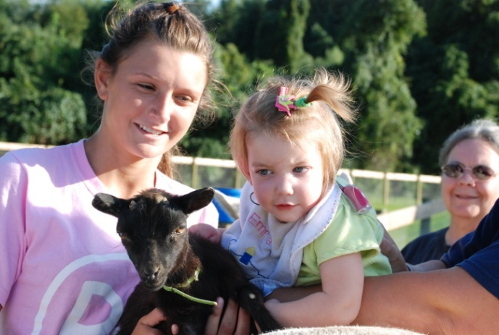
By introducing farm animals to our program, we hope to build the successes of our riding program by offering a hands-on approach to animal care & husbandry. These farm animals teach life lessons, love & respect in a non-traditional manner.

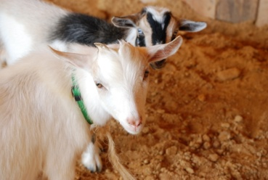
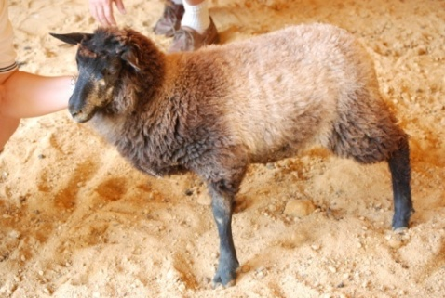

The CENTER
3491 Harris Road
Townsend, DE 19734
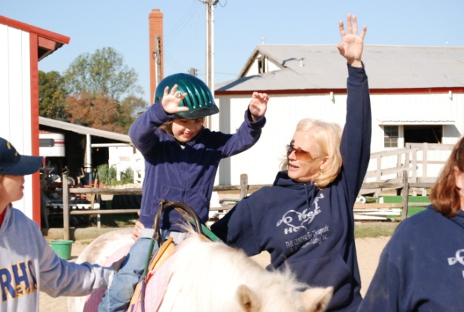
(302) 376-9594

Or visit us on the web at
www.thecenterfortherapeuticriding.com

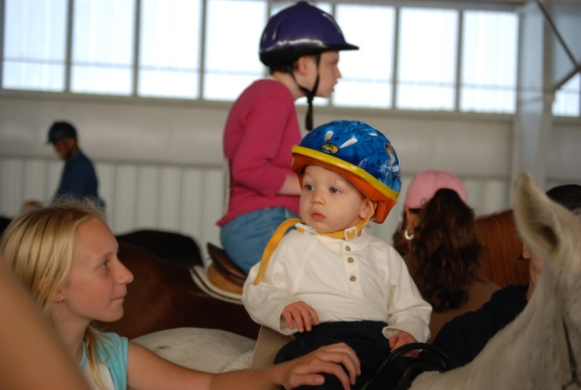

The CENTER
For Therapeutic and
Educational Riding, Inc.
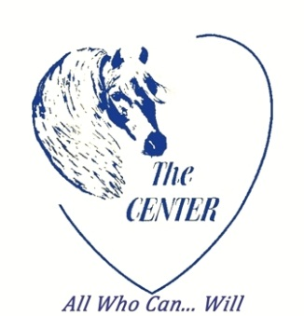

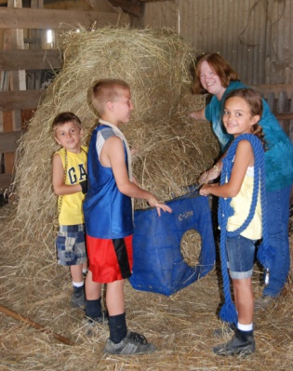
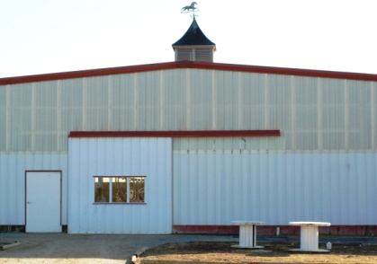
A 501 (c) (3) nonprofit organization

Therapeutic
Horseback
Riding

Therapeutic Horseback Riding is for individuals with physical, cognitive or psychological challenges that limit their ability to participate in a standardized riding program. The purpose of our program is to provide a safe, structured environment for these individuals. These activities allow them to engage in meaningful, age appropriate programs and/or as a viable compliment to physical, occupational or speech therapies, according to the specific needs of the individual.

The multi-dimensional movement of the horse has been shown to positively affect physical, psychological and behavioral functioning in individuals with challenges such as Spine Bifida, Muscular Dystrophy, Cerebral Palsy, Multiple Sclerosis, Down Syndrome, Autism, visually and hearing impaired, emotional, and developmental and learning disabilities.

Due to the special needs of the people we serve, The CENTER is a specialized facility capable of meeting the needs of any participant. Their needs are met through modified equipment, modified instruction, trained staff and specially trained horses not easily found at standard riding facilities.

The CENTER has many different programs to meet the needs of children, adults, cancer survivors, and at-risk youth.

Our Vision

Unlock the potential of individuals with special needs while improving their quality of life.

Our Mission
Provide affordable therapeutic equine and animal activities for individuals with special needs, survivors of cancer, adult day programs, and at risk youth in Delaware and the surrounding areas.

Core Values
Consistency
Dignity
Quality
Availability

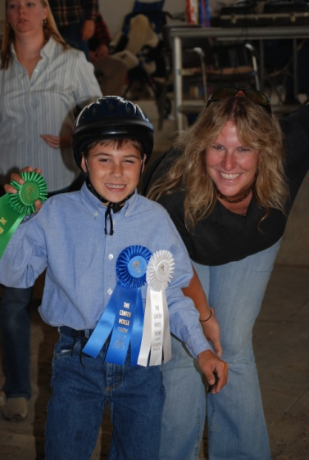

All Who Can…Will

About The CENTER

The CENTER was established in 2002 as a non-profit organization to improve the quality of life for people with special needs or barriers through the use of horses and other farm animals.

Located at C-Line Stables in Townsend, Delaware, facilitated activities will be conducted within the 83 available acres to include use of the indoor arena, outdoor sand ring, stable area and paths throughout the property.

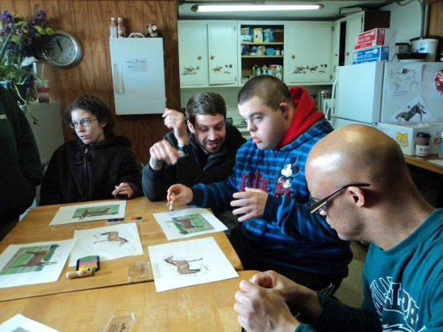

A heated area, located within the main barn, is equipped with everything necessary to conduct classroom teaching, hold seminars and group meetings. An ADA bathroom is available allowing easy access and space for assistance.

Certified Instructors develop programs to meet the specific needs of each rider. Our trained volunteers will be available to provide assistance and maintain a safe environment for all participants.

