The CENTER
for
Therapeutic and Educational
Riding, Inc.
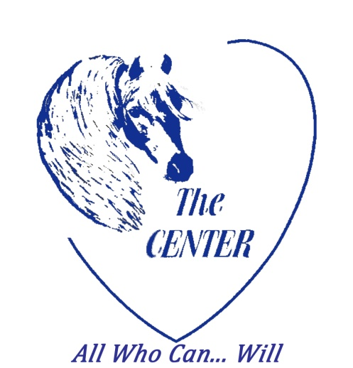

The Warrior Within Program

Uses the horse as a multidimensional modality
in fighting cancer.

The physical, psychological and
emotional benefits of the horse/human
bond have been shown throughout history
to be successful in the healing process.

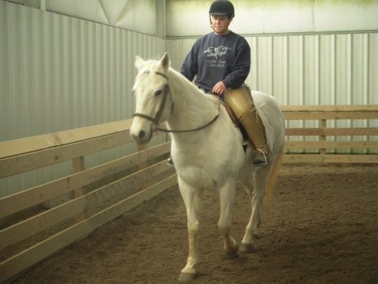

3491 Harris Road
Townsend, DE 19734
(302) 376-9594

The CENTER’s Goals
A multidimensional approach to the wellness
of individuals affected by cancer
- With the understanding that cancer affects
the entire family, “cancer does not affect me,
it affects we”
- To treat all that participate with dignity,
honesty and compassion, never pity
- To understand the limitations of the
human spirit but at the same time strive to
find the thread of continuation
- To remain a solid and consistent presence in a
time of strife
- To allow each participant, their own time,
place and pace on this farm
- To understand that healing, on every level,
is a personal endeavor with no specific
end date
- That change is an opportunity to redefine &
it is not always comfortable
Riding Track Ground Track
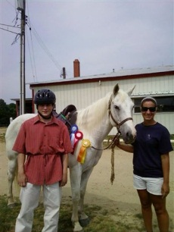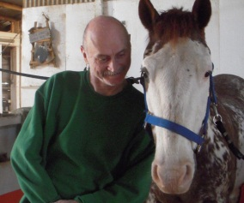

If you are interested in participating in the
Warrior Within Program contact
Kris Fox at: (302) 528-7753

thecenterfortherapeuticriding.com
A 501 (c) (3) nonprofit organization

